Final Year Project Definition Form

Student’s name
CARL MENDOZA

Course
Bsc COMPUTING SCIENCE
Project title
SimplyPie Web application

What is the project about?
We throw away 7 million tonnes of food and drink every year from home, costing us £12.5bn a year (source: http://www.lovefoodhatewaste.com/) and this is mostly due to shoppers buying more than they need each week + insufficient (or the lack of) meal planning, leaving products to be stored until the expiry dates are passed and therefore thrown away.

The SimplyPie app will allow users to significantly reduce the tendency of leaving unused food products past their shelf life by providing a responsive pantry manager that records the items currently stored at home and provides a regular notifications to the user to ensure they are aware of each product’s status.

The app’s core feature is to provide a weekly meal planner, users will be able to view potential recipes with the ready to use ingredients at home to guide their daily planning of meals – taking into account the shelf life of each product to make sure food waste in minimised.

What is the project deliverable?

A working SimplyPie web application, the source code developed will be uploaded to Git.

What is original about this project?

This project will focus on creating an more intuitive interface design than most similar existing pantry inventory/meal planner applications – most of these applications are focused on the mobile versions hence the web equivalent of these software lacking the user friendliness when being used in their mobiles.

This application will also focus on providing the user of means of planning their meals daily, offering them a collection of recipes to choose from, including unique meals inputted by the user and external sources from web. Ingredients prioritisation will also be a core functionality within the application, items that have a short storage life will be prioritised i.e. suggested to the user to be used immediately to ensure that it will not go past the use by date.

Timetable showing main stages in work plan

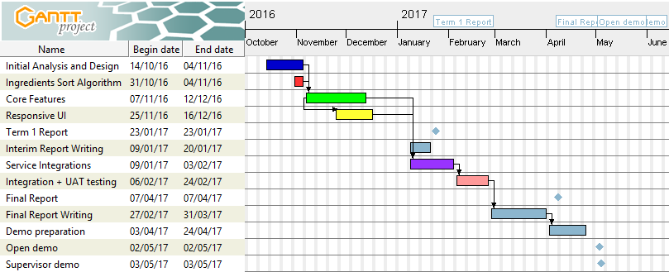

The phases and milestones are as follows:

- Initial Analysis and Design: 14/10/16 - 04/11/16
- Ingredients Sort Algorithm 31/10/16 - 04/11/16
- Core Features 07/11/16 - 12/12/16
- Responsive UI 25/11/16 - 16/12/16
- Interim Report Writing 09/01/17 - 20/01/17
- Term 1 Report 23/01/17
- Service Integrations 09/01/17- 03/02/17
- Integration + UAT testing 06/02/17 - 24/02/17
- Final Report Writing 27/02/17 - 31/03/17
- Final Report 07/04/17
- Demo preparation 03/04/17 - 24/04/17
- Open demo 02/05/17
- Supervisor demo 03/05/17

Student’s signature ____________________________________ Date ________________

Supervisor’s signature _________________________________ Date ________________

Notes: (1) The layout of this form may be adjusted as necessary to fit the needs of any particular project.
(2) Everything except the signatures and dates should be entered using word processing.
(3) You can remove these notes from your final project definition!

